**Name:** Izza

**Sap id:** 49360

**Database Lab**

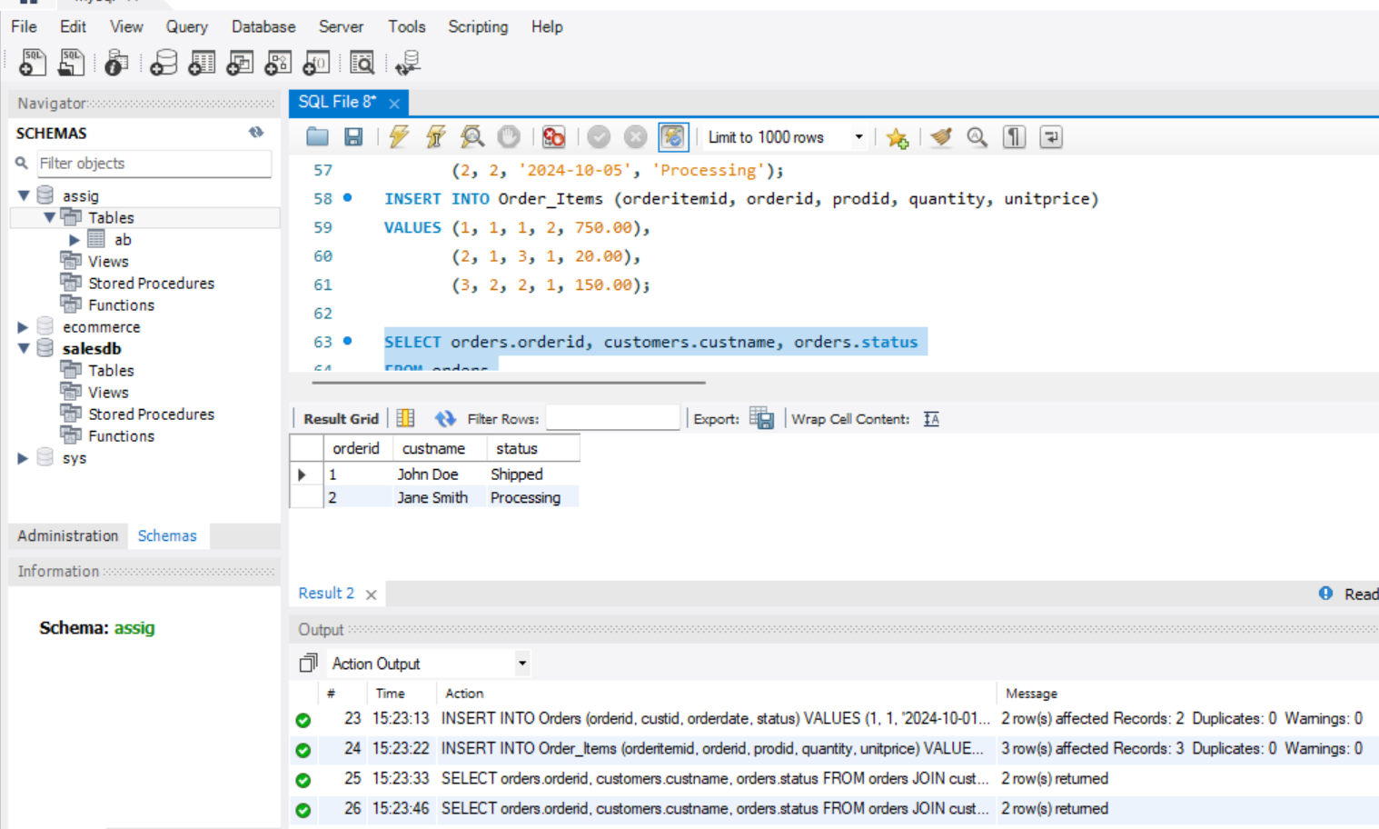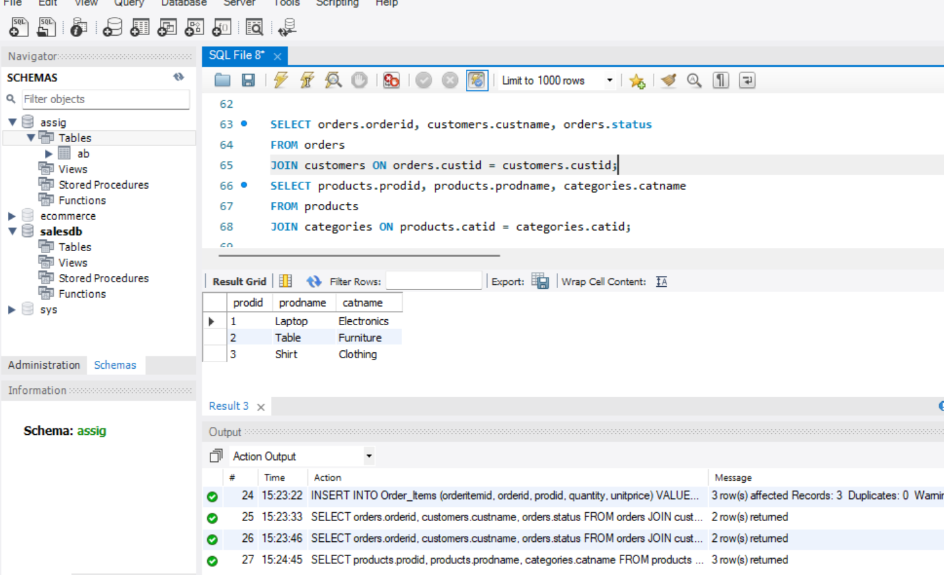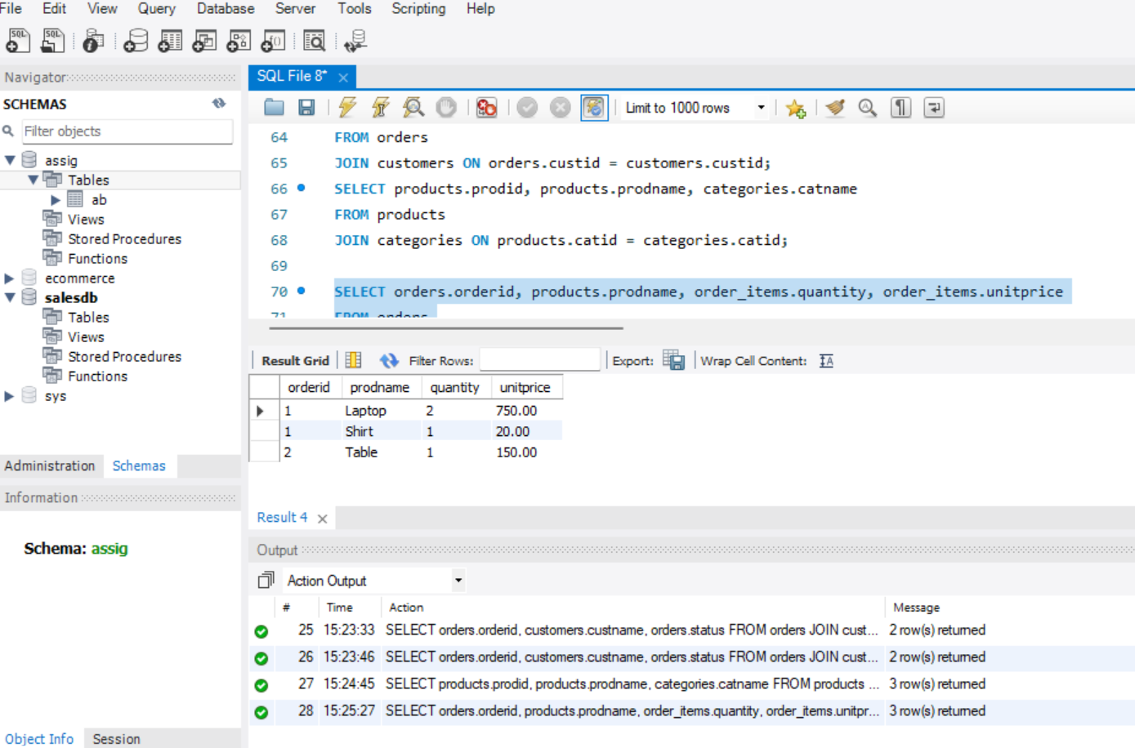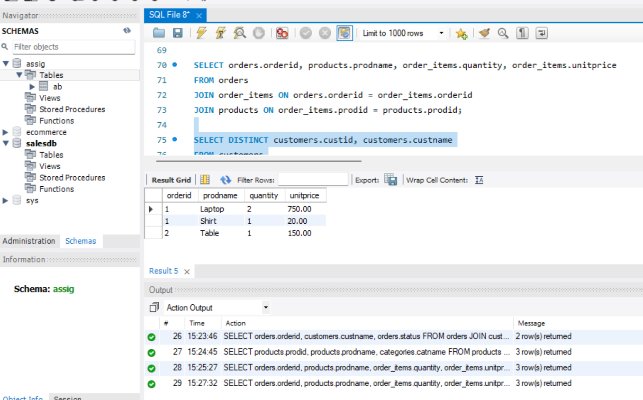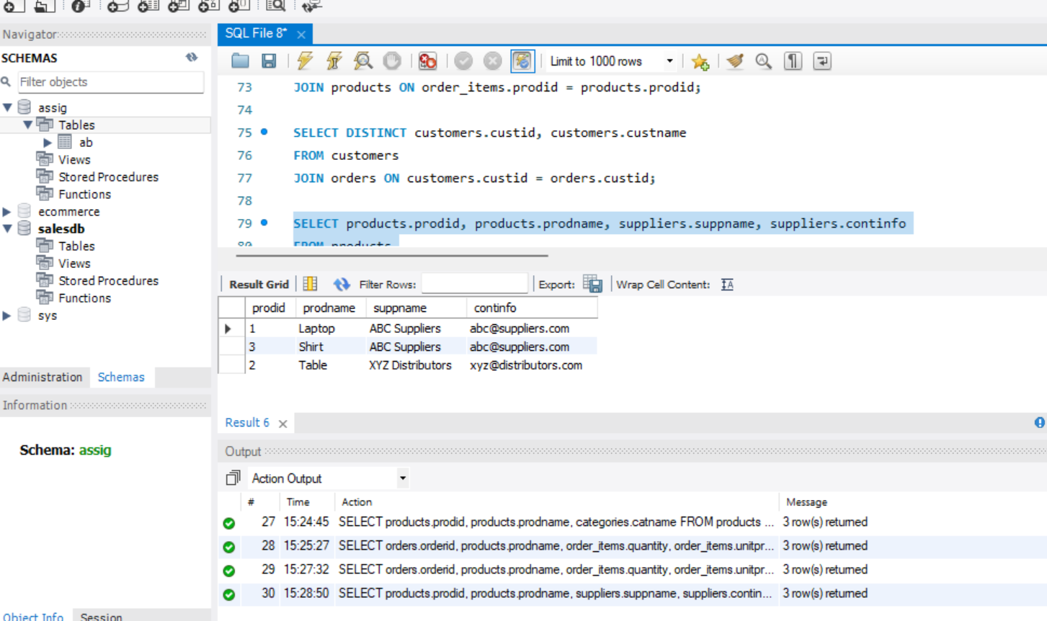

CREATE DATABASE SalesDB;

USE SalesDB;

CREATE TABLE Customers (

custid INT PRIMARY KEY,

custname VARCHAR(100) NOT NULL,

continfo VARCHAR(150)

);

CREATE TABLE Categories (

catid INT PRIMARY KEY,

catname VARCHAR(100) NOT NULL

);

CREATE TABLE Suppliers (

suppid INT PRIMARY KEY,

suppname VARCHAR(100),

continfo VARCHAR(150)

);

CREATE TABLE Products (

prodid INT PRIMARY KEY,

prodname VARCHAR(100) NOT NULL,

catid INT,

suppid INT,

FOREIGN KEY (catid) REFERENCES Categories(catid),

FOREIGN KEY (suppid) REFERENCES Suppliers(suppid)

);

CREATE TABLE Orders (

orderid INT PRIMARY KEY,

custid INT,

orderdate DATE,

status VARCHAR(20),

FOREIGN KEY (custid) REFERENCES Customers(custid)

);

CREATE TABLE Order_Items (

orderitemid INT PRIMARY KEY,

orderid INT,

prodid INT,

quantity INT,

unitprice DECIMAL(10, 2),

FOREIGN KEY (orderid) REFERENCES Orders(orderid),

FOREIGN KEY (prodid) REFERENCES Products(prodid)

);

INSERT INTO Customers (custid, custname, continfo)

VALUES (1, 'John Doe', 'john@example.com'),

(2, 'Jane Smith', 'jane@example.com');

INSERT INTO Categories (catid, catname)

VALUES (1, 'Electronics'),

(2, 'Furniture'),

(3, 'Clothing');

INSERT INTO Suppliers (suppid, suppname, continfo)

VALUES (1, 'ABC Suppliers', 'abc@suppliers.com'),

(2, 'XYZ Distributors', 'xyz@distributors.com');

INSERT INTO Products (prodid, prodname, catid, suppid)

VALUES (1, 'Laptop', 1, 1),

(2, 'Table', 2, 2),

(3, 'Shirt', 3, 1);

INSERT INTO Orders (orderid, custid, orderdate, status)

VALUES (1, 1, '2024-10-01', 'Shipped'),

(2, 2, '2024-10-05', 'Processing');

INSERT INTO Order_Items (orderitemid, orderid, prodid, quantity, unitprice)

VALUES (1, 1, 1, 2, 750.00),

(2, 1, 3, 1, 20.00),

(3, 2, 2, 1, 150.00);

SELECT orders.orderid, customers.custname, orders.status

FROM orders

JOIN customers ON orders.custid = customers.custid;

SELECT products.prodid, products.prodname, categories.catname

FROM products

JOIN categories ON products.catid = categories.catid;

SELECT orders.orderid, products.prodname, order_items.quantity, order_items.unitprice

FROM orders

JOIN order_items ON orders.orderid = order_items.orderid

JOIN products ON order_items.prodid = products.prodid;

SELECT DISTINCT customers.custid, customers.custname

FROM customers

JOIN orders ON customers.custid = orders.custid;

SELECT products.prodid, products.prodname, suppliers.suppname, suppliers.continfo

FROM products

JOIN suppliers ON products.suppid = suppliers.suppid;